UK precision farming company associated with SIMA innovation awards

RDS Technology Ltd was pleased to be associated with 3 of the SIMA Innovation Award winners with ‘special mentions’ for Hardi-Evrard’s EVRARD-ScanApp, an application on smartphone and tablet that simplifies the data entry necessary for the mandatory tracking of phytopharmaceutical products used in each plot. In addition, the McHale Fusion 3 Plus press-baler uses a new binding system that can apply several layers of plastic film in the pressing chamber instead of string or thread. The binding film is stretched much more than thread or string, which provides bales that are denser and so the process of fermentation starts quicker, for better fodder quality. Also receiving an award was Sulky with their ISOBUS centrifuge fertiliser distributor which automatically and independently, on the right and left sides, adjusts the amount to be dispensed. The adjusted amount is very close to that recommended. Zones of under and over-dosing are reduced and transition zones, where the recommended dose is changed, are managed more finely. The cost of inputs is therefore optimised.

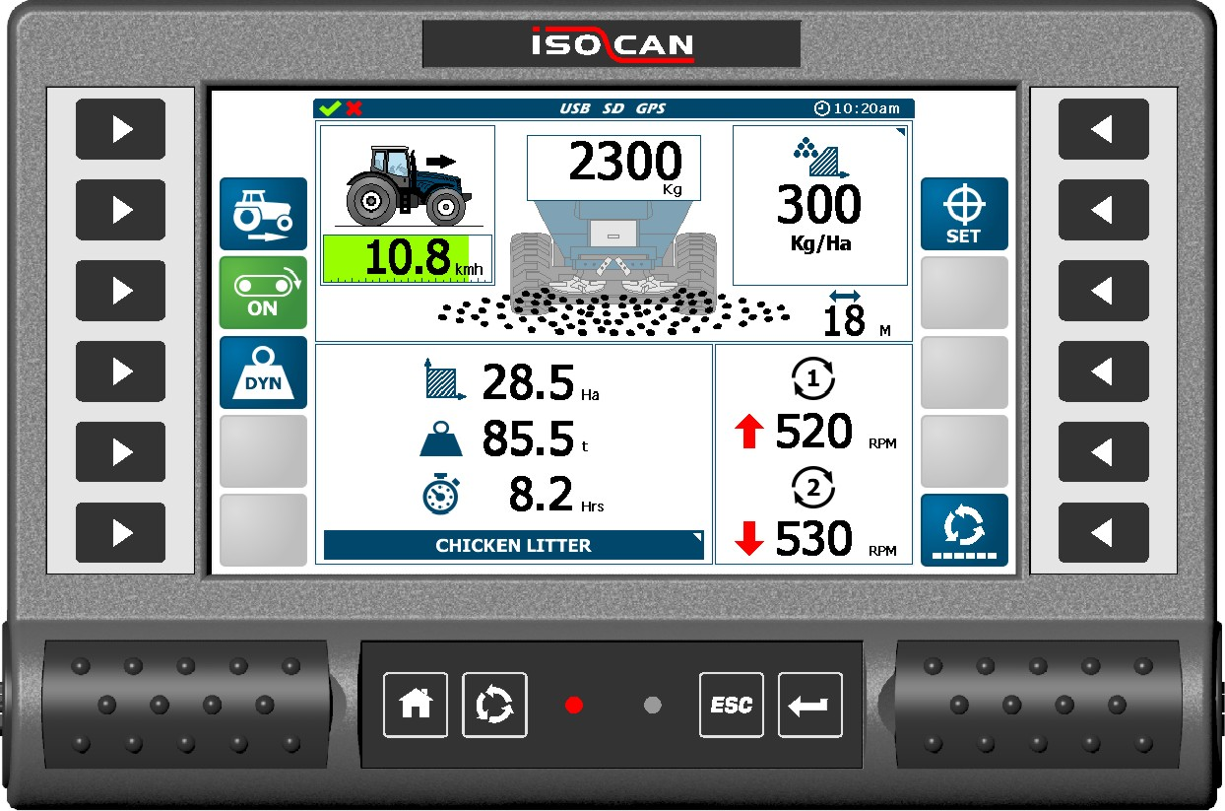
RDS also gave market debuts to several new products. With increasing demand for accurate and consistent application of farm yard manure and granular fertilizer, RDS has developed the iSOCAN Apollo system that will control the floor conveyor speed of the spreader proportional to forward speed. Dynamic calibration from on-board loadcells enables the system to maintain accuracy irrespective of product density changes. This complete control provides spreading accuracy but also simplifies operation for the user. The iSOCAN also contains 2x camera inputs along with GPS Guidance and VRA capabilities (see iSOCAN Enhancements).

Using the 4.3” touchscreen G-CAN instrument the M-Spread is a simple solution providing basic electro- hydraulic control of a manure spreader i.e. floor speed control, slurry gate up/down etc. Additional sensors enable operational information to be viewed such as area covered, distance travelled, job duration. Also offers the possibility for export to a USB stick for record keeping purposes. An optional capability is to interface with Epsilon sensors for a static weighing feature to bring further data to the operator i.e. average tonnes/ha, tonnes spread etc.
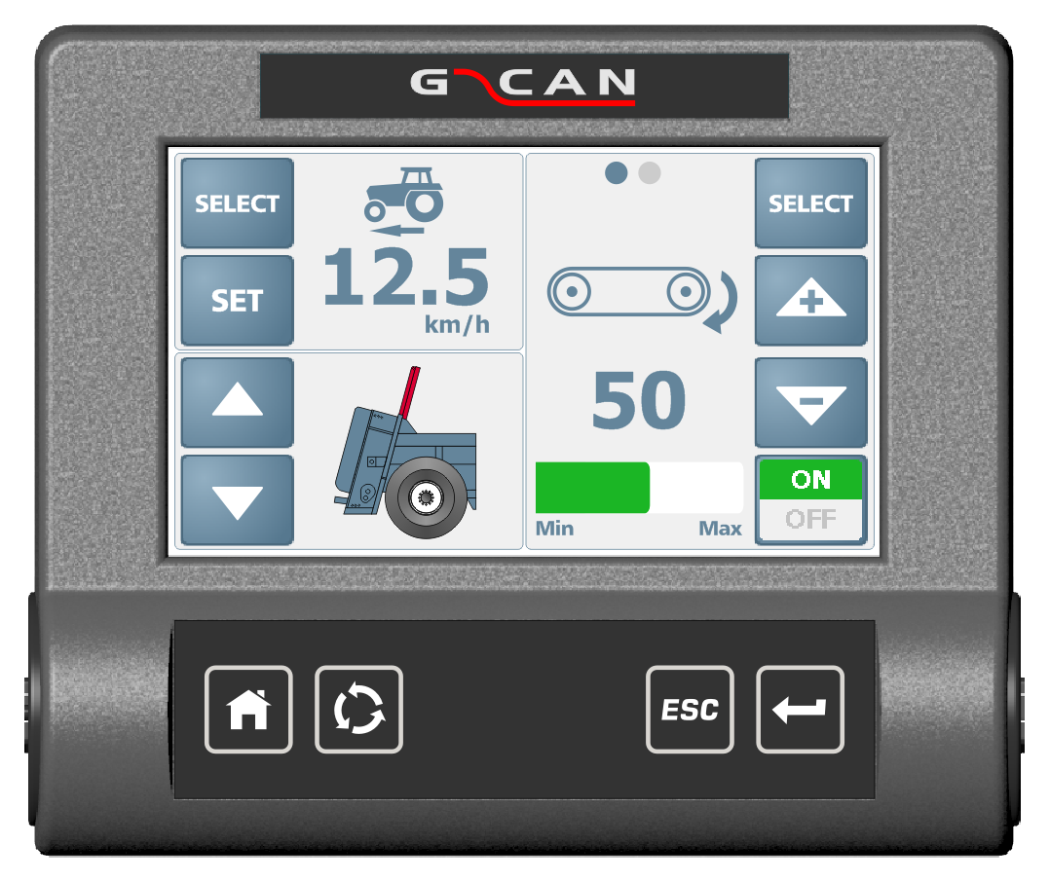

After successful field testing in the Autumn of 2014 the iSOCAN Artemis electric drive system for seed drills is now fully available, and optionally for Spring 2015 will also offer integrated blockage functionality with sensors supplied by RDS. The optical sensors mounted in the air pipes will monitor seed flow and provide an alarm to the operator in the event of a blockage. In conjunction with the electric metering drive this makes for a comprehensive control and monitoring system for the modern seed drill.

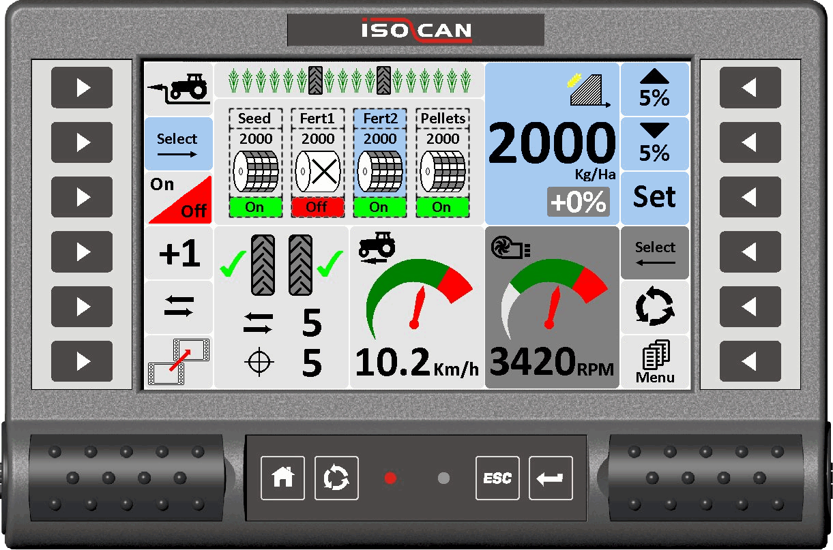

With an increasing demand to provide operation via an ISOBUS UT, the Artemis Bridge Module designed to operate with the iSOCAN has now been enhanced to enable Artemis-equipped seed drills to work with the modern ISOBUS-equipped tractors. As per the iSOCAN Artemis the software will be configurable to operate upto 4 electric motors, each of which can be for a different product if required. Precision Farming functionality will be supported by the integrated ISOBUS TC GEO within the terminal.

It is increasingly important for the farm management process to know exactly how crops are yielding. Using the well proven, accurate and reliable optical yield measurement technique, the iSOCeres builds on the popular PSi Ceres to provide the combine OEM yield monitoring via any compliant ISOBUS UT. Data is presented on the UT with the Ceres Object Pool loaded from the ISOCeres ECU. Yield mapping will be supported by the integrated ISOBUS TC GEO within the terminal.

